Valiant Theme Game

Game Features



Locked Symbol Frame



Expanding Wild



Expanding Wild



Lighting Re-spins



Free Spins:



Game Math



Math File 96.25%



Math File 94%





Technical Specs

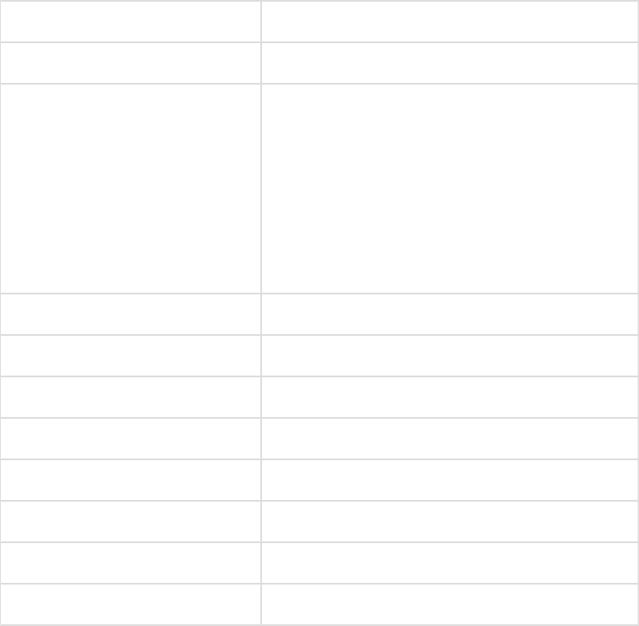

|  |  |
| --- | --- |
| **Number of Paylines / Ways** | 1024 |
| **Reel Type** | 5x4 |



|  |  |  |
| --- | --- | --- |
| **Free Spins** | Yes |  |
| **Special Features** | Locked Symbol Frames |  |
|  | Expanding Wild |  |
|  | Lighting Re-spins |  |
|  | Free Spins |  |
| **Winning functionality** | Leftmost to right |  |
| **Number of Symbols** | 11 |  |
| **RTP** | 96.25% and 94% |  |
| **Volatility** | Medium |  |
| **Hit Rate** | 37-38 % base game |  |
| **Max Exposure** | e.g. 1000 multiplier x total bet |  |
| **Default bet** | min - $0.50 |  |
| **Max bet** |  |
|  | default - $2.00 |  |
|  | max - $100.00 |  |
|  |  |  |

Lines/Ways

1024 ways of winning. Payouts are when 3 or more symbols for combinations from the 3rd reel on.

List of symbols and Paytable

|  |  |  |  |  |
| --- | --- | --- | --- | --- |
| **ID in engine** | **Symbol Name** | **3** | **4** | **5** |
|  |  |  |  |  |
| 0 | 10 | 12 | 15 | 50 |
| 1 | J | 12 | 20 | 75 |
| 2 | Q | 12 | 20 | 100 |
| 3 | K | 12 | 25 | 150 |
| 4 | A | 25 | 30 | 200 |
| 5 | Face 1 | 30 | 100 | 300 |
| 6 | Face 2 | 50 | 150 | 500 |
| 7 | Face 3 | 75 | 200 | 1000 |
| 8 | Face 4 | 100 | 500 | 1500 |
| 9 | n/a (Mathematician can add if needed) |  |  |  |
| 10 | Wild | 0 | 0 | 2000 |
| 11 | Scatter |  |  |  |
| 12 | Locked Frame |  |  |  |
|  |  |  |  |  |

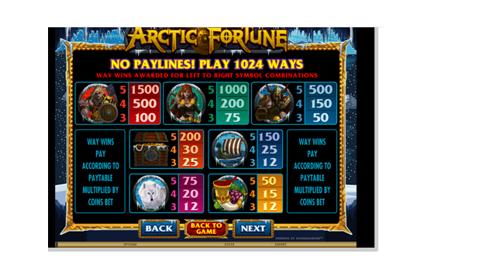

Base game

During Base game, the player wins with combination of symbols and player can trigger lighting re-spins feature or Free Spins



Game Features

**Locked Symbol Frame**

During Base game, when a Wild Symbol appears anywhere in the Wheelbox, a Symbol Frame will appear and stay on the reel. Several Symbol Frames can appear and be locked on the reels



The Symbol Frames can convert to a Wild on any Spin at random



**Expanding Wild**

**Expanding Wild**

Whenever the Symbol Frames cover the whole reel vertically. They transform into an Expanded Wild (Faith).



Example



**Lighting Re-spins**

When a the Stacked Wild on a Reel expands converting into an Expanded Wild (Faith), 3 Re-spins will be awarded to the player



The expanded Wild will be held on the Reels along with all the other Locked Symbol Frames while the Re-Spins occur



New Wilds can appear leaving more Locked Frames on each re-spin, each new Locked Frame will reset the Re-spins counter to 3



When 4 Stacked Symbol Frames are in the same reel aligned vertically, they will also transform to an Expanded Wild (Faith) and remain locked in the Reel awarding more prizes



The feature ends when:



Re-spins counter reaches 0



All positions are covered with Expanded Wilds (Faith)



**Free Spins:**

3 or more Scatters from the Leftmost reel to the right award 12 Free Spins During Symbol Frames Feature can also be triggered during the Free Spins.

Random Multipliers



Game Math

**Math File 96.25%**

Attach math excels here.

**Math File 94%**

Attach math excels here.

Storyboards - gameflow

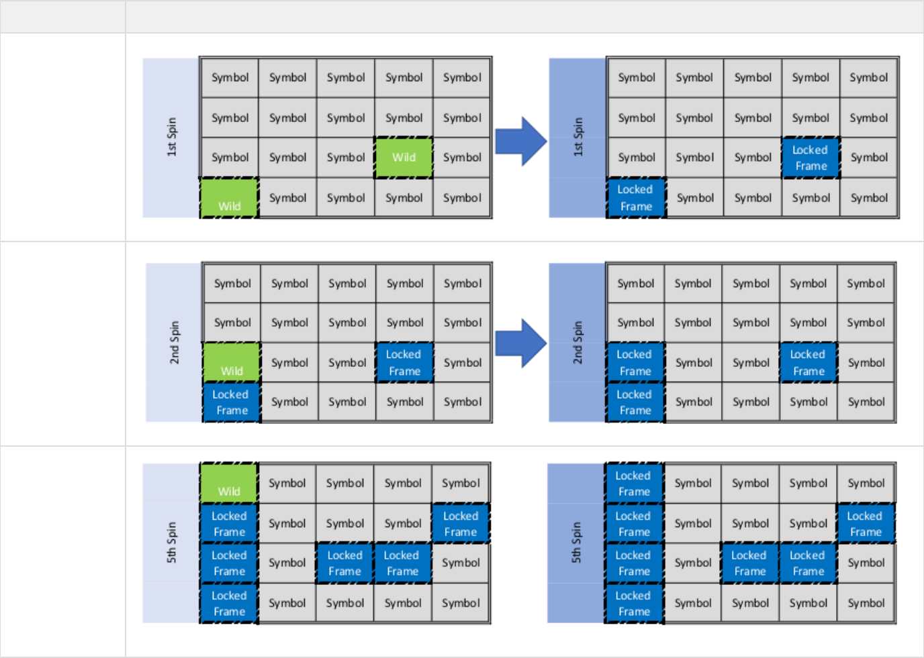

**Event** **Image**

Normal Base Game Spin

Normal Base Game Spin

with Locked Symbol Frames

Expanding Wild

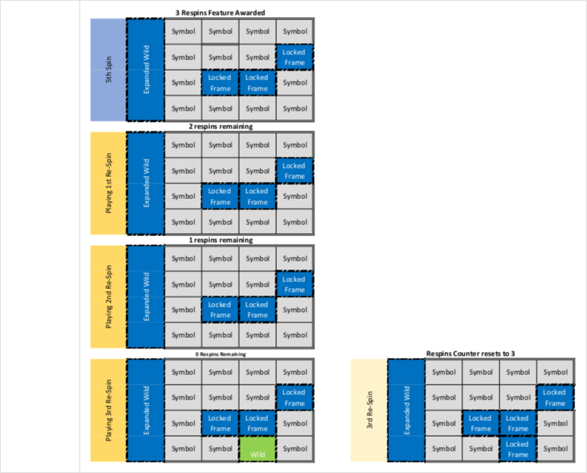Re-spins

Feature

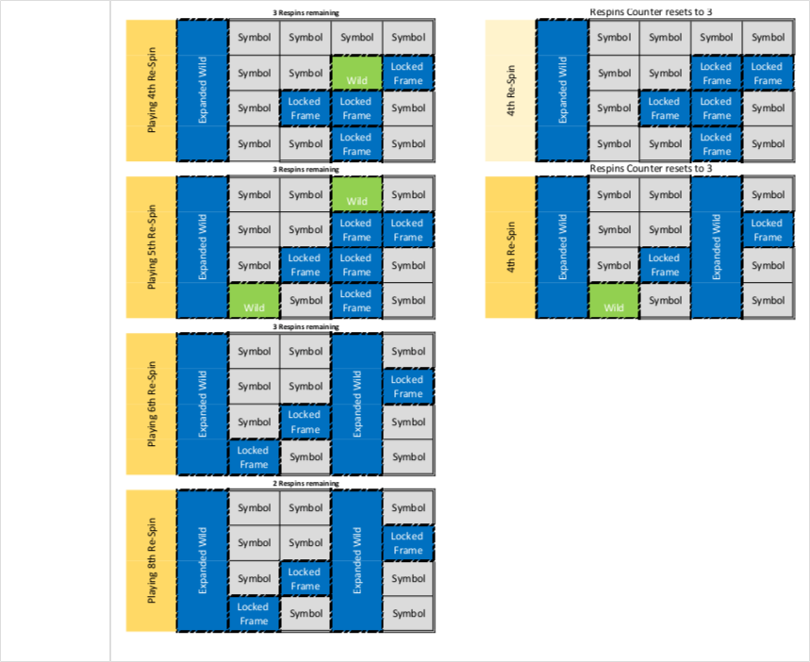More Extra Wilds can appear in Re-spins

Valiant – Questions

1. 96.25% version – roughly what RTP split between base and free spins? Base Game: 38.95% Free Spins: 40%, Lightning Link Feature: 17.3%
2. 94% version – roughly what RTP split between base and free spins? Base Game: 37.42% Free Spins: 40%, Lightning Link Feature: 16.58%
3. Any paytable in mind? See <https://free-slots-no-download.com/microgaming/21193-arctic-fortune/> paytable – care re coins versus credits. Min bet 0.50
   1. Wilds do not pay on there own – only 5 of a kind wilds pays on its own. Otherwise wilds substitute for highest possible winning combination of other symbols.
4. Approx.. Max exposure (x total bet) @5,000 x total bet from single win
5. Base game:
   1. Target hit rate? Between 37% – 38%
   2. ‘Wheelbox’ means symbol grid
   3. Says ‘when a Wild Symbol appears…..Symbol Frames **can** appear and be locked on the reels’ – This suggests that wilds don’t always leave a frame. The answer is, that always there’s a Wild, they will always leave a Locked Frame in the reel in its position.
      1. What if a wild land in a position that already has a frame? Nothing happens, that frame should remain in there
      2. When frames held is next spin paid or free? Keep paying for the spins until any entire reel is full of frames – then ‘respins’ are free.
      3. Bet size adjustment abuse? (bet low until lots of frames held and then increase bet). We need to reset the locked frames in the grid if the bet size is changed. Please note this in PAR sheet.
6. Lightning Re-spins
   1. Says ‘When a the **Stacked Wild** on a Reel expands’ – Does this mean wilds should be stacked on reels? No, wild are not stacked on reels.
   2. Respins paid or free? Re-spins are Free
   3. Approx trigger frequency? 1 each 75 spins.
   4. Are wins paid after each respin or just at end of respin sequence? Asses symbol grid after each re-spin and calculate wins, accumulate and pay full value at the end of the feature.
   5. Presume all frames disappear at end of respin sequence? Yes
   6. Roughly what percentage of Lightning respin sequences do you envisage: Mathematician can adjust as needed – rough guide below
      1. One more reel being filled with frames – 30%
      2. Two more reels – 15%
      3. Three more reels – Rare 3%
      4. Full grid being filled – Really rare 1%
   7. Can a lightning respin sequence end in Nil win? No, it shouldn’t. If respin meter decrements to 0 and there has been no win during respin sequence then continue further respins until the first wins happens.
   8. Scatter assessment and free spin trigger timing:
      1. no Scatters on respin reels for Lightning Re-spins Feature.
      2. In case of 3+ Scatters on the same paid spin that triggers Lightning re-spins feature, play first the Free Spins and then Lightning Re-spins feature

Change the order. First play Lightning Re-spins feature games and then Free Spins. Cause Each Free Spin game can lead more Lightning Re-spins feature games.

1. Free spins:
   1. Scatters on all reels? Yes.
   2. Possible for more than one scatter to appear on same reel at a time? No
   3. Approx free spin trigger frequency 1 each 200 spins?
   4. Target hit rate? (treating respin series as 1 win) Between 37% – 38%.
   5. Free spins – target average payout – i.e. x times total bet @80x Total Bet
   6. Random Multiplier 1x – 8x after each full wild reel during Free Spin.
      1. guaranteed at least one Lightning Re-spin Feature inside the Free Spins. If there’s no Lightning re-spin during the first 11 Free Spins, force the 12 free spin to trigger the Lightning re-spin feature.
      2. One more reel being filled with frames – 30% of FS series
      3. Two more reels – 15%
      4. Three more reels – Rare 3%
      5. Full grid being filled – Really rare 1%
      6. Multipliers to be added together.